Kunhui Zhang (001563549)

**Program Structures & Algorithms**

**Fall 2021**

**Assignment No. 1** **(Random Walk)**

* **Task:**

1. C**onclusion** about the relationship between *d*and*n*;
2. E**vidence** to support that relationship (screen shot and/or graph and/or spreadsheet);
3. C**ode** (*RandomWalk.java* plus anything else that you changed or created);
4. A **screen shot** of the unit tests all passing.

* **Relationship Conclusion:**

n: the number of steps;

d: the distance between the terminal point and original point.

$$E(d) =\sqrt{n}$$

* **Evidence to support the conclusion:**

1. **Output :**

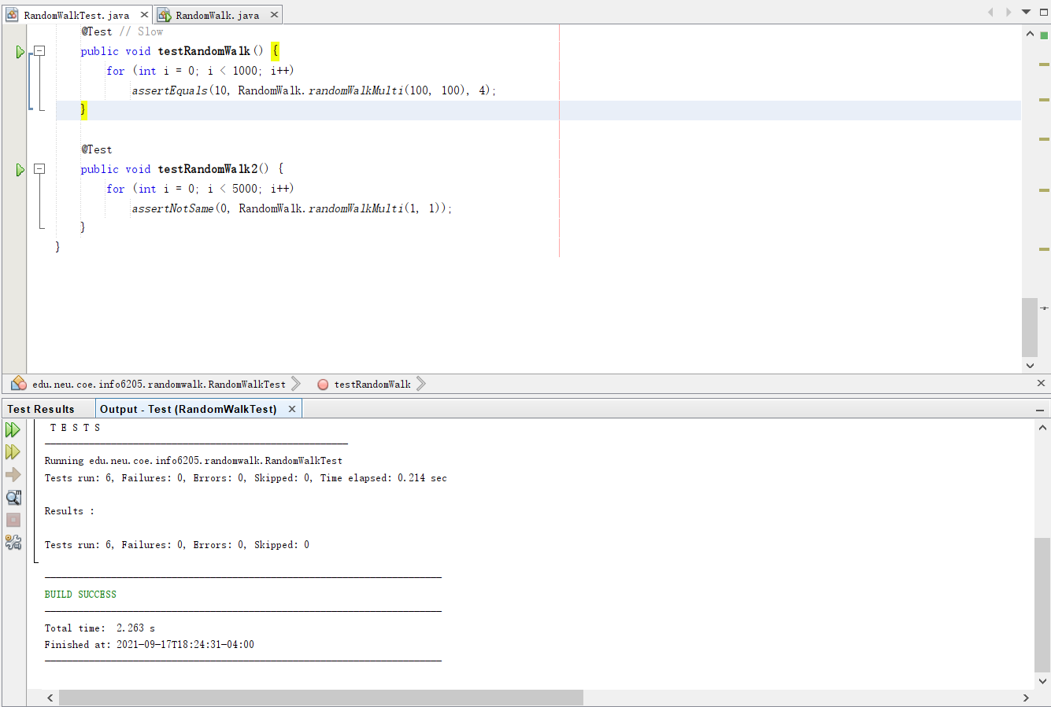

**Picture1.The output of test**

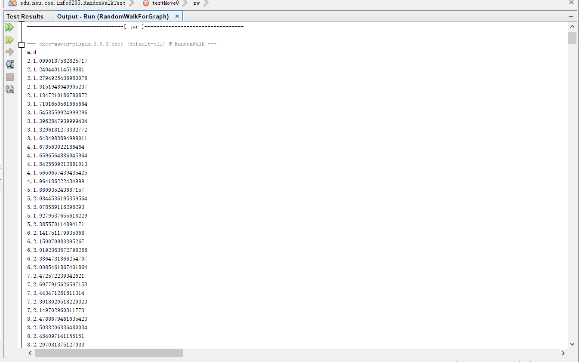

**Picture2.The output(data) of program for evidence**

1. **Graphical Representation:**

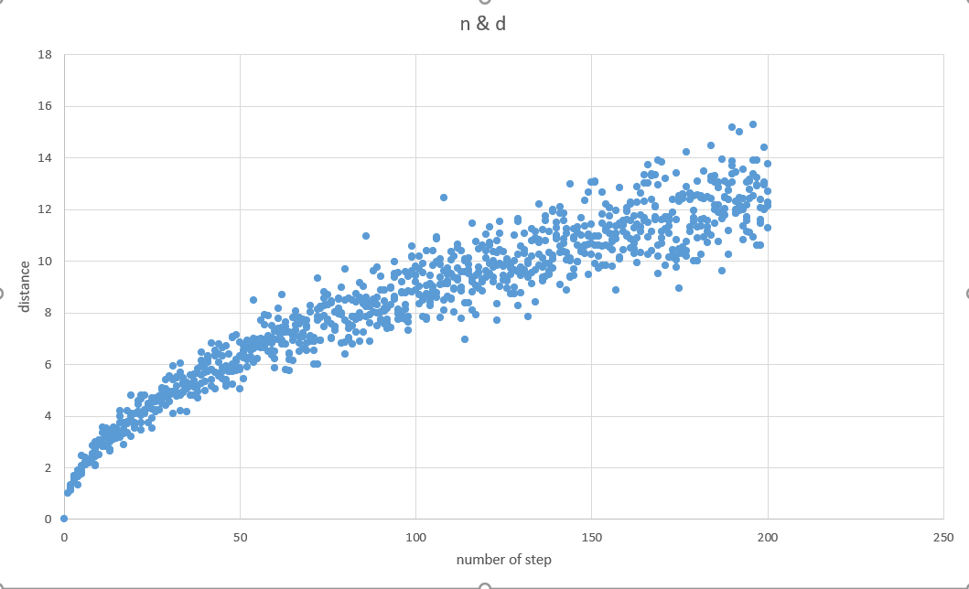

**Picture3.The graph of relationship between n and d**

* **Unit tests result:**

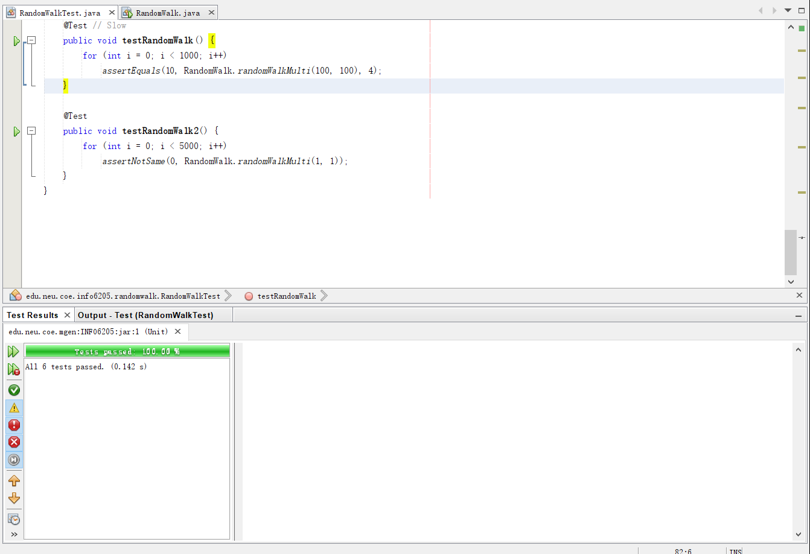

**Picture4.The test result**